Multi-decadal variability of Oyashio Intermediate Water causing high biological productivity in the North Pacific.
Research Press Release: July 15, 2021
We predict that a rapid warming and changes in essential water properties will occur from the mid-2020’s for the following 10 years.
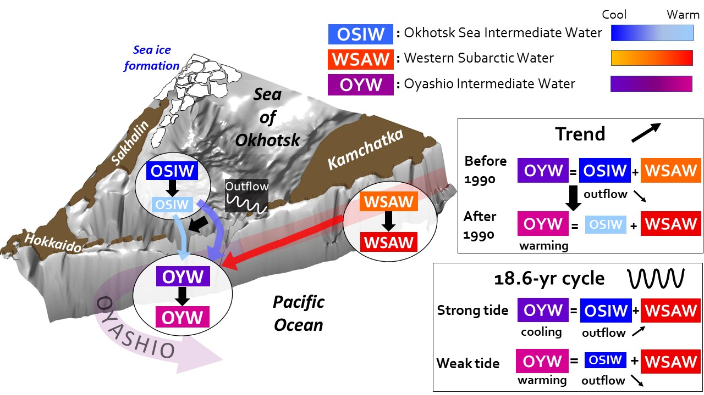
Fig. 1. Schematic of the formation of Oyashio Intermediate Water (OYW), its changes and future forecast. OYW (purple/pink) is formed by mixing of the warmer Western Subarctic Water (WSAW, orange/red) and the colder Okhotsk Sea Intermediate Water (OSIW, blue/light blue). The properties (temperature, salinity, iron content) of OYW vary as the mixing ratio between WSAW and OSIW changes. The map delineates how the different water masses are being modified over the long-term warming trend: OSIW and WSAW warm (color change within the white boxes), and in addition the outflow of OSIW to the North Pacific decreases (wide blue arrow becomes a thin light blue arrow). These variations lead to the strong warming of OYW.
The Oyashio is a cold-water current of the Pacific Ocean flowing from east of the Kuril Islands to the North of Honshu Island in Japan. It is well-known for its very high biological productivity, essential for both fauna diversity, fisheries activities, and intake of CO2 by phytoplankton (Fig. 2). This very high productivity is caused by the meeting in the Oyashio of cold and iron-rich waters from the Sea of Okhotsk, and nutrient-rich waters from the warmer subarctic Pacific.
However, the outflow of water from the Sea of Okhotsk may not be constant, which might affect the fragile nutrient balance in Oyashio. Global warming has caused a decrease of sea ice production in the Sea of Okhotsk, a key element of the North Pacific overturning, in which cold surface waters from the Sea of Okhotsk sink to mid-depth before being exported to the North Pacific. An 18.6-year oscillation cycle caused by the tide may also affect this outflow.
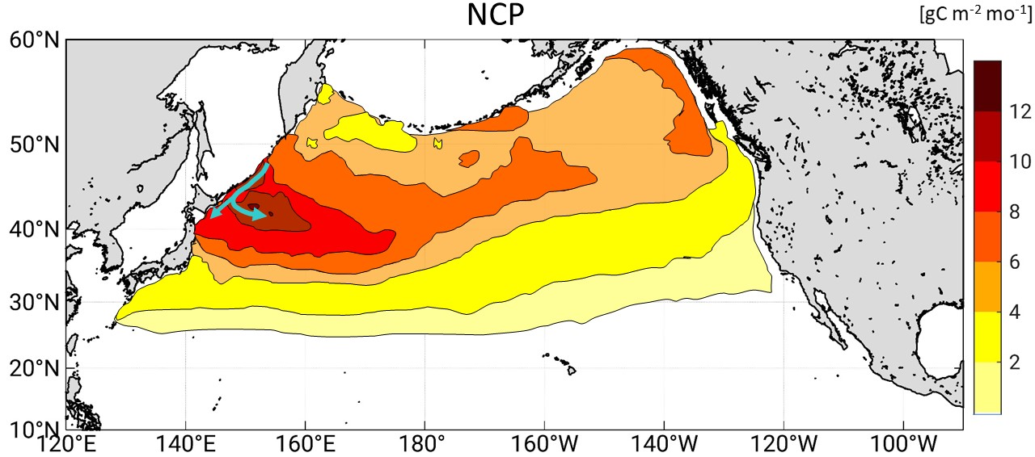
Fig. 2. Net Community Production (NCP) in the North Pacific Ocean. The highest NCP values extend from the Kuril Islands and the northeast of Japan towards the east, which corresponds to the path of the Oyashio Current (green arrows). This figure is based on data published by Yasunaka et al. (2021).
To investigate the variability of Oyashio Intermediate Water, Prof. Kay. I. Ohshima and V. Mensah, from Hokkaido University, analyzed temperature and salinity data acquired from 1930 until 2020. The researchers compiled seasonal data from the Sea of Okhotsk, the Oyashio, and the subarctic Pacific off the coast of Kamchatka.
The researchers found that the outflow of cold water from the Sea of Okhotsk has decreased in winter by 30% in about 40 years, equivalent to the decrease in sea ice production in this sea. In addition, the two source waters of Oyashio Intermediate Water, namely Okhotsk Sea Intermediate Water and Western Subarctic Water have warmed. The combination of these two factors lead to an increase of temperature of 0.12°C per decade for the OYW (Fig. 3).
The team from Hokkaido University also confirmed a previous theory that the 18.6-year variability of the tide affects the Sea of Okhotsk outflow, because tide enhances the exchange of water between this sea and the North Pacific. This outflow increases during strong tide, which makes the Oyashio Intermediate Water colder, and probably richer in iron. But the outflow weakens during weak tide years, leading to a warmer, potentially less iron-rich Oyashio (Fig. 3).
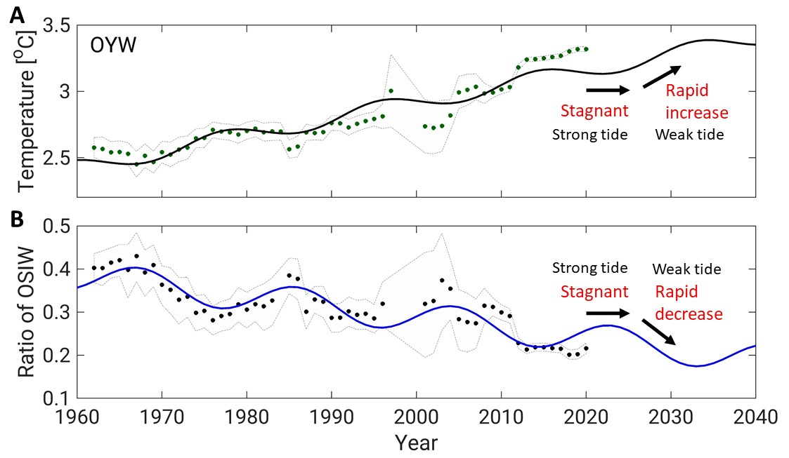
Fig. 3 Time series of observed and predicted Oyashio Intermediate Water Temperature (A) and Okhotsk Sea Intermediate Water content in the Oyashio (B) in winter on the 26.9 kg·m⁻³ density level. Dots represent observations, and lines represent predictions based on the long-term trend (increasing or decreasing slope) and the 18.6-yr tidal oscillations.
“Because the linear-trend of global warming and the ~20-year tidal cycle are predictable, we could forecast Oyashio properties until 2040. We expect the outflow from the Sea of Okhotsk to decrease by 50% and Oyashio Intermediate Water to warm by 1 °C between 1960 and 2040.” says Kay. I. Ohshima. “The tide is now intensifying and will be strongest by 2025, so OYW warming should pause until then. However, after 2025 the tide will enter its weaker phase and less cold water will flow out of the Sea of Okhotsk for the following 10 years”. pursued V. Mensah, the first author of the study. The two scientists expect that the weaker tide associated with global warming will lead to enhanced warming -and possibly a drop in iron content- of the water in the Oyashio until the mid-2030’s and wonder how these changes could affect the biological productivity in the North Pacific.

Original Article:
Mensah Vigan¹, Kay. I. Ohshima^{1,2}
Weakened overturning and tide control the properties of Oyashio Intermediate Water, a key water mass in the North Pacific.
Scientific Reports. July 15, 2021.
DOI:10.1038/s41598-021-93901-6
Funding:
This work is supported by Grants-in-Aid for Scientific Research #17H01157 and #20H05707 from the Ministry of Education, Culture, Sports, Science, and Technology of Japan.

Contacts:
Professor Kay I. Ohshima
Institute of Low Temperature Science, Hokkaido University
Tel: +81-11-706-5481
Email:ohshima[at]lowtem.hokudai.ac.jp

